Group name: **Yellow** panda  
Group member: Ang Jin Kuan  
 Nigel Chen Chin Hao  
 Bryan Tan Shao Xuan  
 Low Qing Ning

--- Setting up database ---

1. Install XAMPP (Installer have been provided in the file)
2. Open XAMPP Control Panel
3. Click on start on both Apache and MySQL

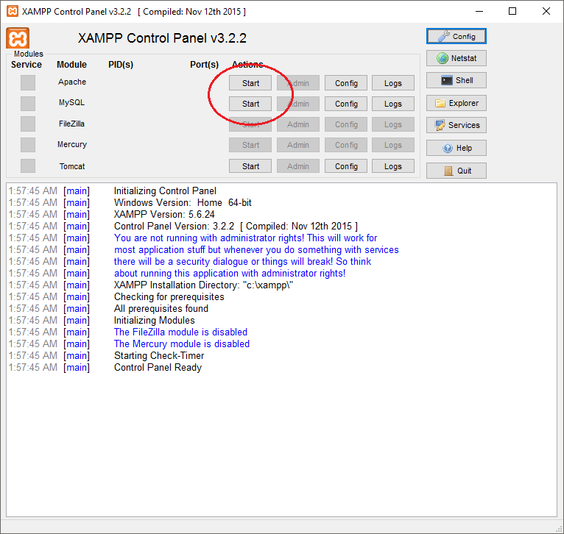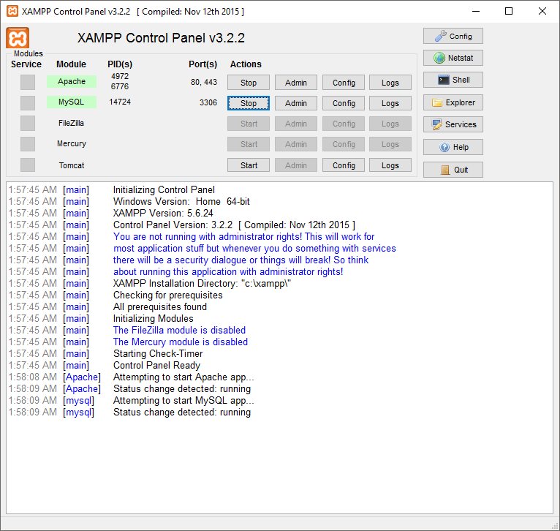

1. Launch a browser e.g. Chrome and type in the following URL:  
   <http://localhost/dashboard/>
2. Click on phpMyAdmin

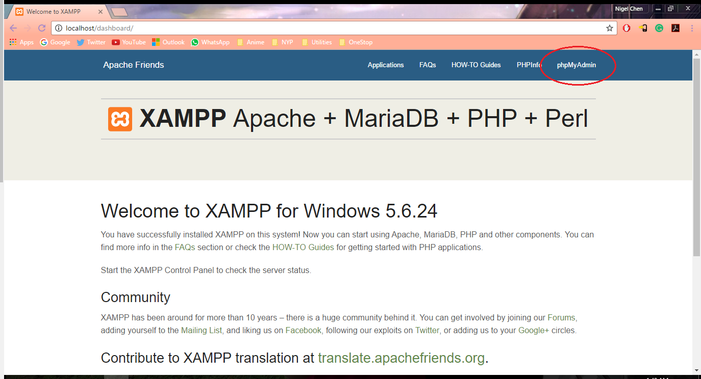

1. Click on new

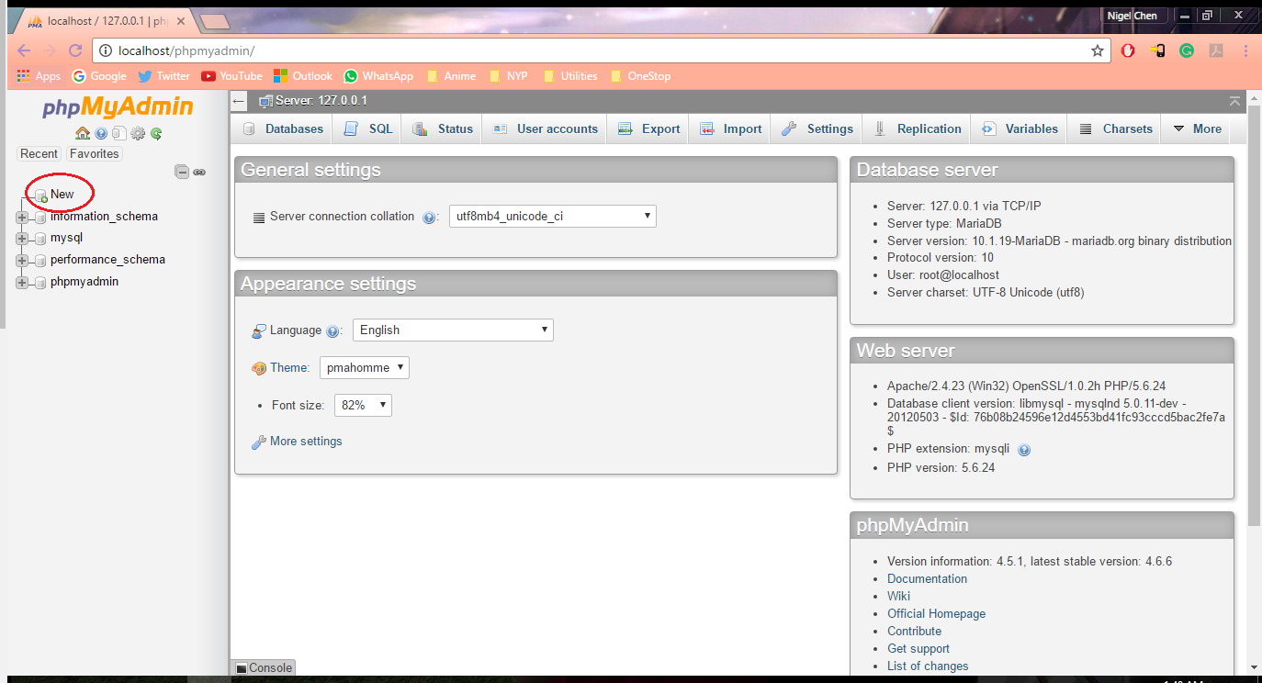

1. Create a database name: myjobleh  
   (No space and no caps)  
   And then click on create

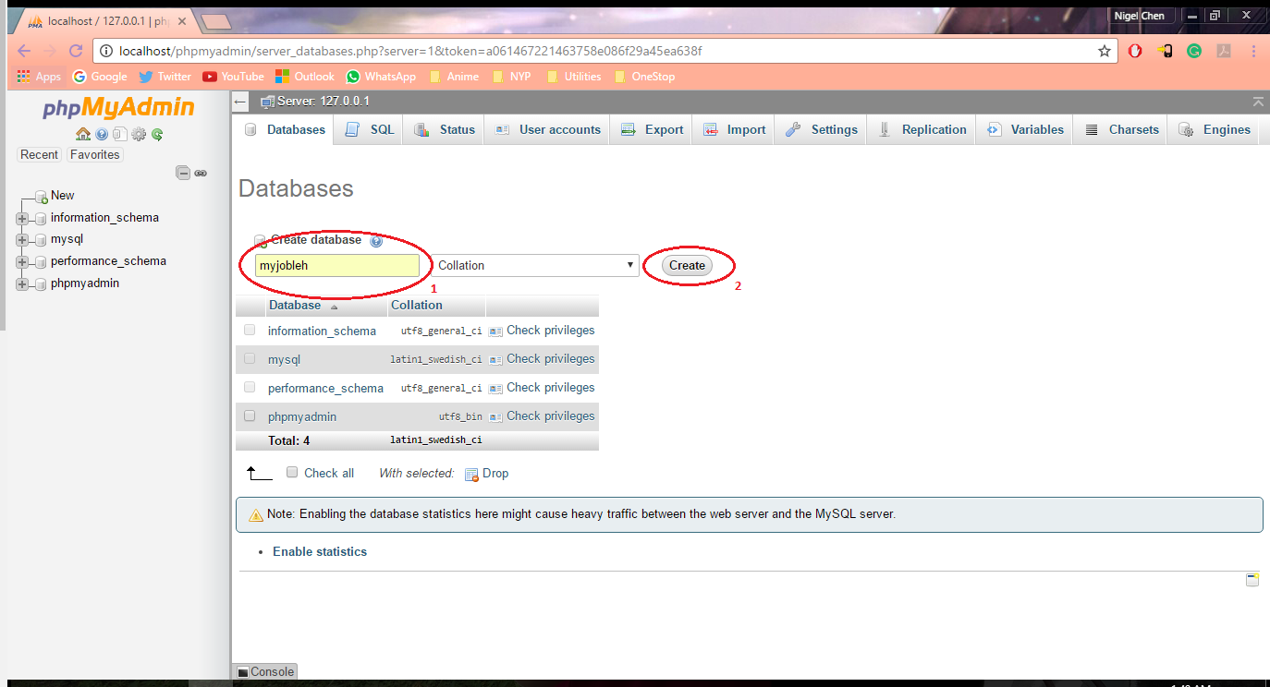

1. Click on import

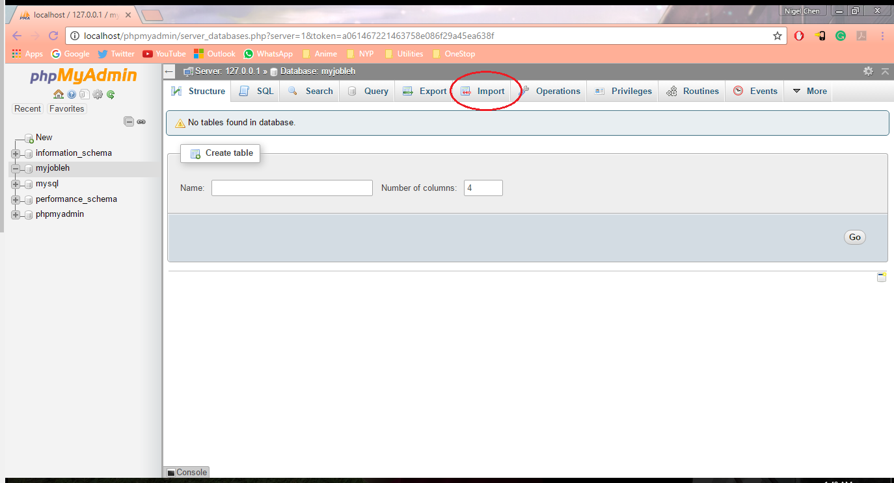

1. Click on choose file and find the following .sql file:  
   myjobleh.sql (Provided in the file)  
   Click on go afterwards

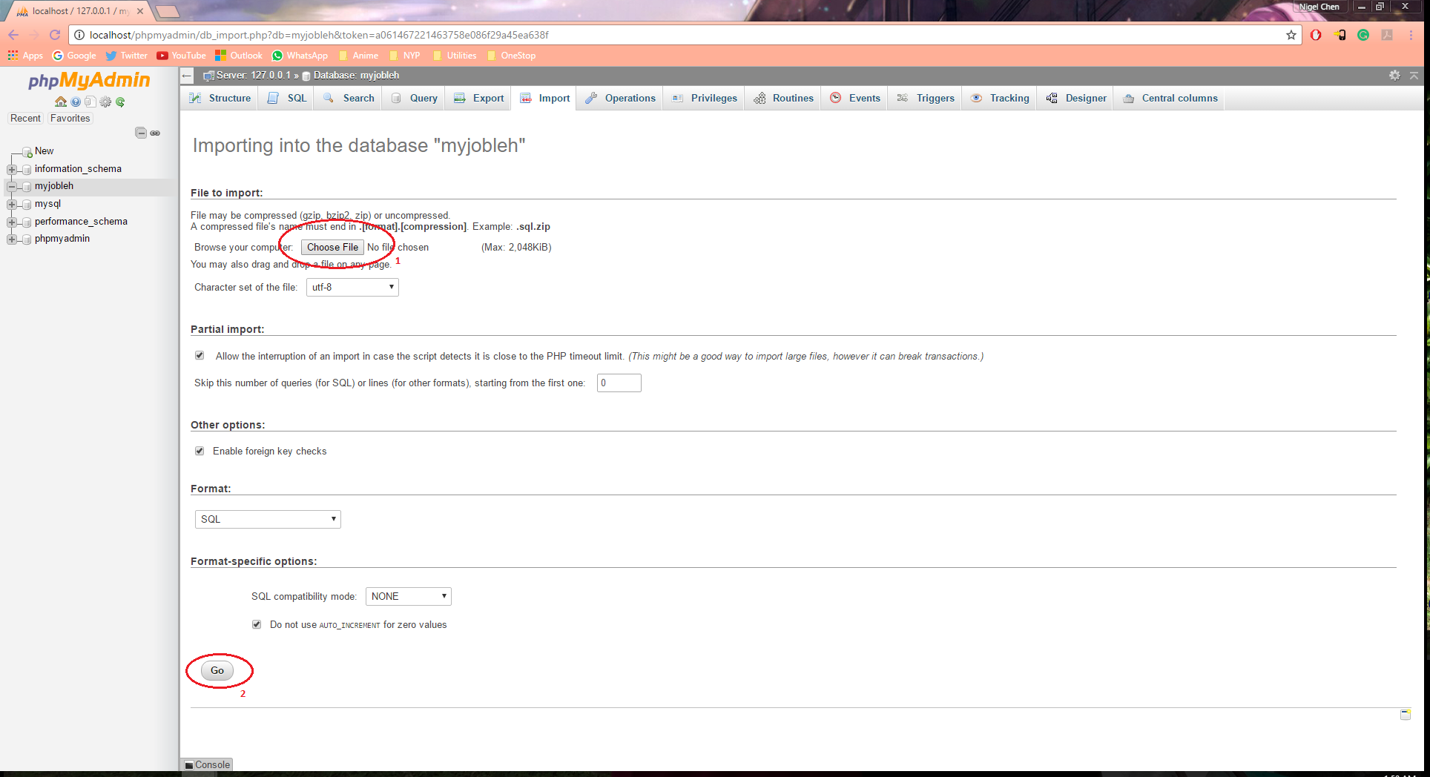

1. You have successfully imported the database.
2. Run Java IDE – Eclipse

--- Things to take note ---

1. Make sure you are not connected to school Wi-Fi. If not email function will not be able to work.